Mobiquity Assignment

By Nirmal Dholakhia

API Tests information

For Running and Installation information Please refer README.doc

Additional Information about Tests

1. Positive and Negative test cases have been created for the given workflow in the assignment
2. Cypress is a well-known End-to-End test tool used in market, hence I have used same with Chai Assertion Library

1. Tests has been executed on Circle-CI Platform and result snapshot is pasted below

Artifacts/Reports are also uploaded at respective paths

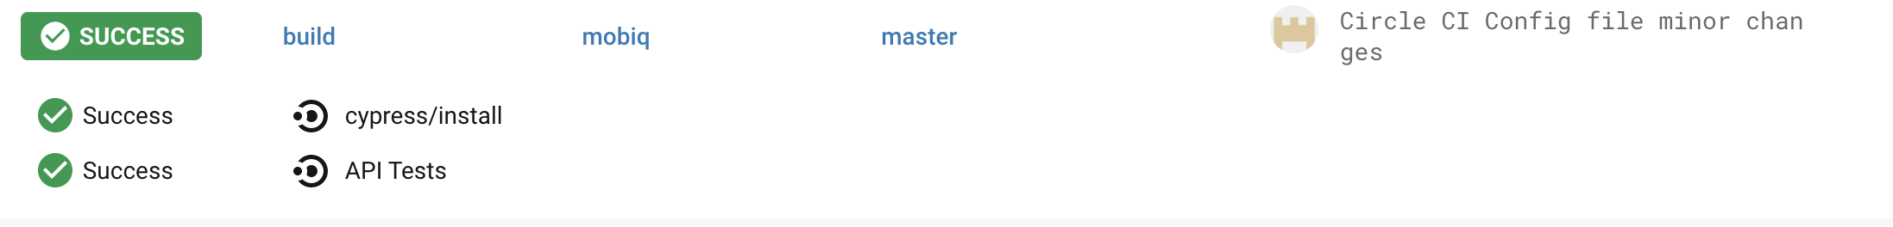

1. For Reporting I have used Mochawesome package and Report is being available at path provided in README doc

1. I was not able to perform test coverage of the application and hence haven’t included that in report